Chapter 13: Wired LANs – Ethernet
Table of Contents
13.1 IEEE Standards 2
13.2 Standard Ethernet 3
MAC Frames 3
Frame Sizes 5
MAC Addresses 6
Collision Detection 7

13.1 IEEE Standards
The standards related to Wired LAN are from IEEE 802.3. The most commonly used standard is called Ethernet.

As can be seen in the diagram above, the Ethernet protocol is divided between the MAC Layer in the Data Link Layer and the Physical Layer.
In reality, what protocol will be used in these two layers depends entirely on what standard is being used in the transmission medium. If the transmission medium is using Ethernet, we use Ethernet protocols. If it is using a Token Ring, we use Token Ring protocols and so one.
However, the layers above these will be unaffected by these changes. This allows networks with different physical implementations to connect with each other.

13.2 Standard Ethernet
There are actually several versions of Ethernet.

Currently, Fast Ethernet is commonly used, but higher speed versions are available.

MAC Frames
In Wired LANs, we transfer frames. These frames are also called 802.3 MAC Frames. The format for these frames is like this:

The first two sections, Preamble and SFD, are actually part of the Physical Layer Header, meaning they are attached when the frame gets to the Physical Layer, not in the MAC Layer. The Preamble indicates that a new frame is about to start. It has 56 bits of alternative 1s and 0s. The SFD indicates that the actual frame starts just after this byte. It acts as a delimiter and has the format 10101011.
The Data and Padding comes from the Upper Layers, so that part can also stay vague for now.
The Destination Address and Source Address are being added in the MAC Layer. These are MAC Addresses, or Physical Addresses. The Source Address is simple enough to find, since it is the MAC Address of the current machine, but the Destination Address is the MAC Address of the next node. This needs to be retrieved using the ARP Protocol. The ARP Protocol in turn needs to know the IP Address of the next node in order to retrieve its MAC Address. The IP Address is provided by the Network Layer from a Routing Table. However, the ARP Protocol is handled by the Network Layer and is not being executed by the Data Link Layer right now. Essentially, by the time we are creating the MAC Frame, we already know the Destination Address.
The Length or Type represents either the length of the packet or what type of packet is being sent.

Frame Sizes
The MAC Frame has a minimum and a maximum size. The minimum size is 64 bytes and the maximum size is 1518 bytes.

As can be seen in the diagram above, the difference in size is due to the size variations in the actual Data and Padding section, which can vary from 46 bytes to 1500 bytes.
The minimum frame size restriction is because having frames smaller than that will prevent CSMA-CD from detecting frame collision. The frame needs to be transmitting for at least double the propagation time.
Of course, this depends on the speed of the connection. The scenario we are looking at here is for standard ethernet, which works at 10 MBps. Essentially, the maximum propagation time is $25.6 μs$ and since we are transmitting at $10 MBps$, the size needs to be $10 MBps×25.6 μs=512 bits$ or $64 bytes$. Faster connections will require a larger minimum size, so that the frame is transmitting for enough time.
The maximum frame size restriction is to prevent monopolization of the network and because having frames that are larger would require larger buffers, which is expensive.

MAC Addresses
The source and destination addresses are of the following format:

There are 6 divisions, each with 2 hex digits, giving a total of 12 hex digits. Each hex digit is 4 bits, giving a total of 48 bits or 6 bytes.

A Unicast MAC Address has an even LSB in the first division, for example $4A:30:10:21:10:1A$, since $A=1010$. This indicates that there is only one destination.
A Multicast MAC Address has an odd LSB in the first division, for example $47:20:1B:2E:08:EE$, since $7=0111$. This indicates that there are multiple destinations.
A Broadcast MAC Address just has all the digits set to $F$, as in $FF:FF:FF:FF:FF:FF$. This indicates that the message is meant for all nodes in the network.

On the transmission medium, each byte of the address is sent out from left-to-right. For each byte, the bits are sent out right-to-left. Thus, $47:20:1B:2E:08:EE$ is sent as $11100010 00000100 11011000 01110100 00010000 01110111$. Notice how $47$, which is $0100$ $0111$ in binary, is on the left but the bits are flipped.

Collision Detection
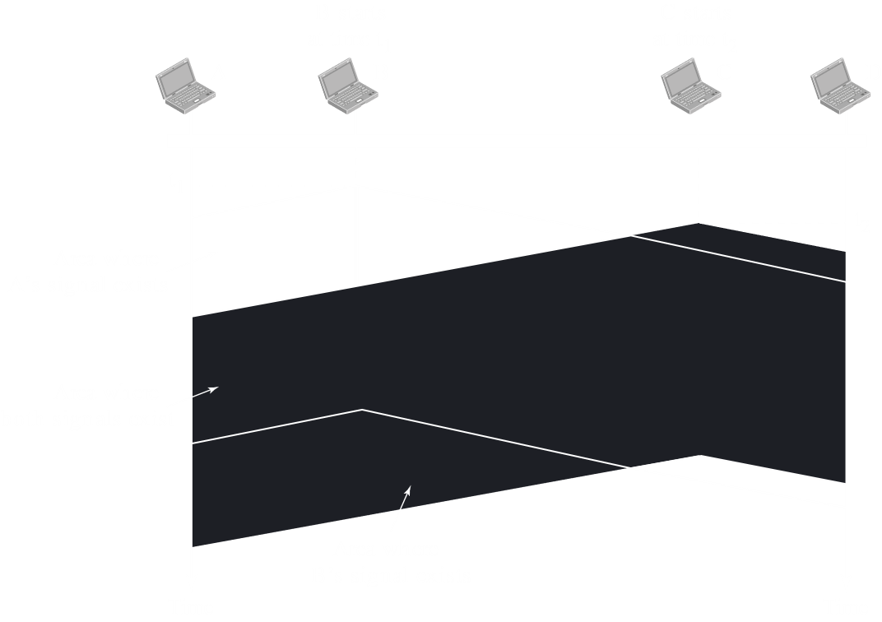
We have previously seen how collision detection in CSMA-CD works. The diagram above should serve as a reminder.

